LAB CYCLE 3_SHELL SCRIPTING

1.Add two Numbers
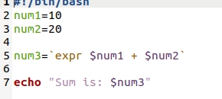

output
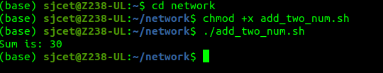

2.swap two numbers

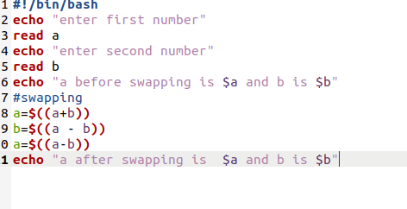

output

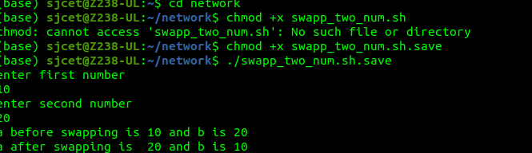

3.program to perfrom ls command

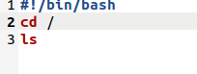

output
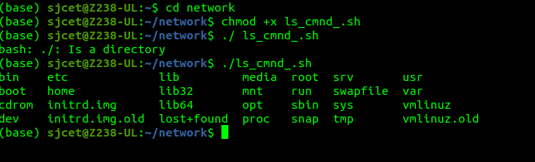

4. : program to print the current process id ( $$ )

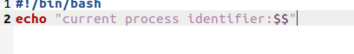

output:
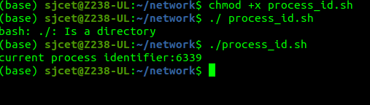

5.write a programm to find area and circumfrence of the circle

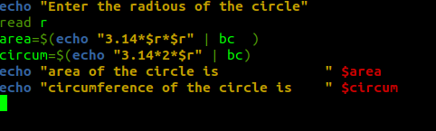

output
